Lesson Plan - Virtual LEP
Learning Area: Biological Science/Critiquing exploring and investigating ideas
Learning Experience Focus: Science/ Design and Technologies Processes and Production Skills
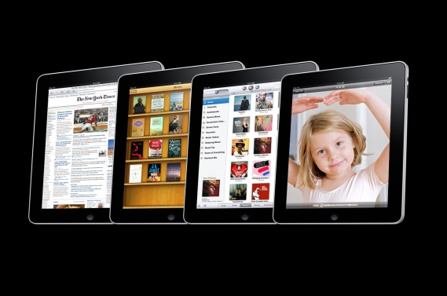
Step 1: Locate classroom I-Pads

Step 2: Enter App store and type in Worm World into the search engine
Step 3: Install the ‘Worm World’ App

You are now ready to conduct your lesson!!
Sit your students down with their I-pads and together navigate through the worm world welcome page and through the initial instructions with the students. Remember to show the students that you can pause and recommence the game at any time.
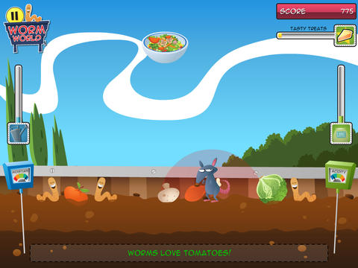

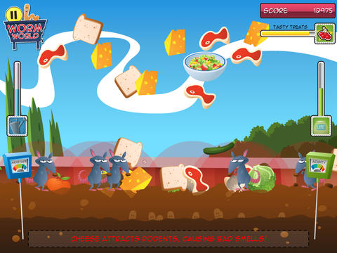

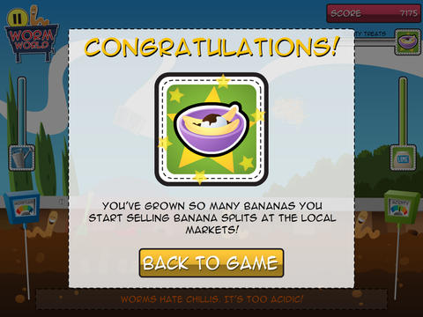

This lesson can be effectively implemented into the Year 1 Science and Design and Technology Curriculum as it teaches student cause and effect, as well as how to sustain growth and care for living animals. It allows students to discover the necessary means to support a plant structure by creating fertile soil and maintaining soil levels and worm production in a virtual sense. This can lead to a whole class project to create a real worm farm and harvest the fertiliser for a vegetable garden or other food produce such as herbs or fruit gardens.
Australian Curriculum outcomes:
- 2.2 Investigate and play with technologies, materials and systems used to identify properties and create designed solutions for personal and local community needs
- Living things live in different places where their needs are met (ACSSU211)
- People use science in their daily lives, including when caring for their environment and living things (ACSHE022)
Elaborations:
- Students relate science to human activities in the home and school, such as caring for garden plants and animals.
- Identify products that can be designed and produced from plants and animals for example fertiliser from worm farms.
- Demonstrate how science is used in activities such as caring for plants and animals.
- Students identify that soil is a type of habitat that supports living things.
References:
Australian Curriculum Assessment and Reporting Authority. (2013, February). Draft Australian Curriculum: Technologies. Retrieved from Australian Curriculum: http://consultation.australiancurriculum.edu.au/Static/docs/Technologies/Draft%20Australian%20Curriculum%20Technologies%20-%20February%202013.pdf
Australian Curriculum Assessment and Reporting Authority. (2014). Australian Curriculum Science Year 1. Retrieved from Australian Curriculum: http://www.australiancurriculum.edu.au/Science/Curriculum/F-10#level1
Brisbane City Council. (2012). Worm World. Retrieved January 10, 2014, from Scootle.com: https://www.scootle.edu.au/ec/viewMetadata.action?id=M016807&q=worm+world&topic=&start=0&sort=relevance&contentsource=&contentprovider=&resourcetype=&v=text&showLomCommercialResources=false&field=title&field=text.all&field=topic&contenttype=all&contenttyp

