Divide It Up Puppies: Mathematics resource for I-pad users

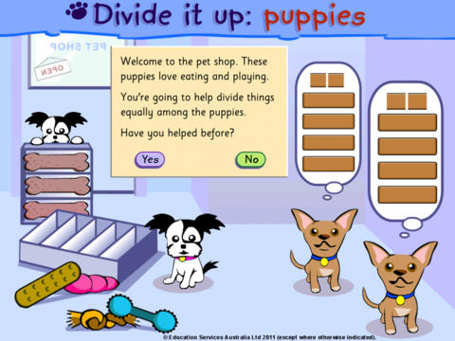

Mathematics / 4 / Number and Algebra / Money and financial mathematics
Curriculum content descriptions
Solve problems involving purchases and the calculation of change to the nearest five cents with and without digital technologies
Elaborations
- recognising that not all countries use dollars and cents, eg India uses rupees.
- carrying out calculations in another currency as well as in dollars and cents, and identifying both as decimal systems
General capabilities
- Literacy
- Numeracy
- Intercultural understanding
- Critical and creative thinking
- ICT competence
Mathematics / 5 / Number and Algebra / Number and place value
Curriculum content descriptions
Use efficient mental and written strategies and apply appropriate digital technologies to solve problems
Elaborations
- using calculators to check the reasonableness of answers
General capabilities
- Literacy
- Numeracy
- Critical and creative thinking
- ICT competence

